Comsats University Islamabad, Attock Campus

Department of Computer Science

Assignment No : 4
Course Name: IS Lab
Program: BSE-4

Submitted to:Ma’am Ambreen Gul
Submitted by: Mubassir Bashir
Registration Number: 023

TASK1
- p and q are prime numbers used only for teaching.
- n is product p times q.
- phi is computed as (p minus 1) times (q minus 1) using operator.sub and operator.mul so the code shows the arithmetic clearly.
- e is chosen as 65537 because it is standard and makes exponentiation efficient.
- egcd implements the extended Euclidean algorithm to return gcd and coefficients.
- modinv uses egcd to get modular inverse of e mod phi which is the private exponent d.
- text_to_int and int_to_text convert between bytes and integer so we can do math on the message.
- encrypt_int and decrypt_int use modular exponentiation pow with three arguments for efficiency and clarity.
- The demo checks that the integer representation of the message is smaller than n. With very small p and q you must use very short messages or apply block splitting.
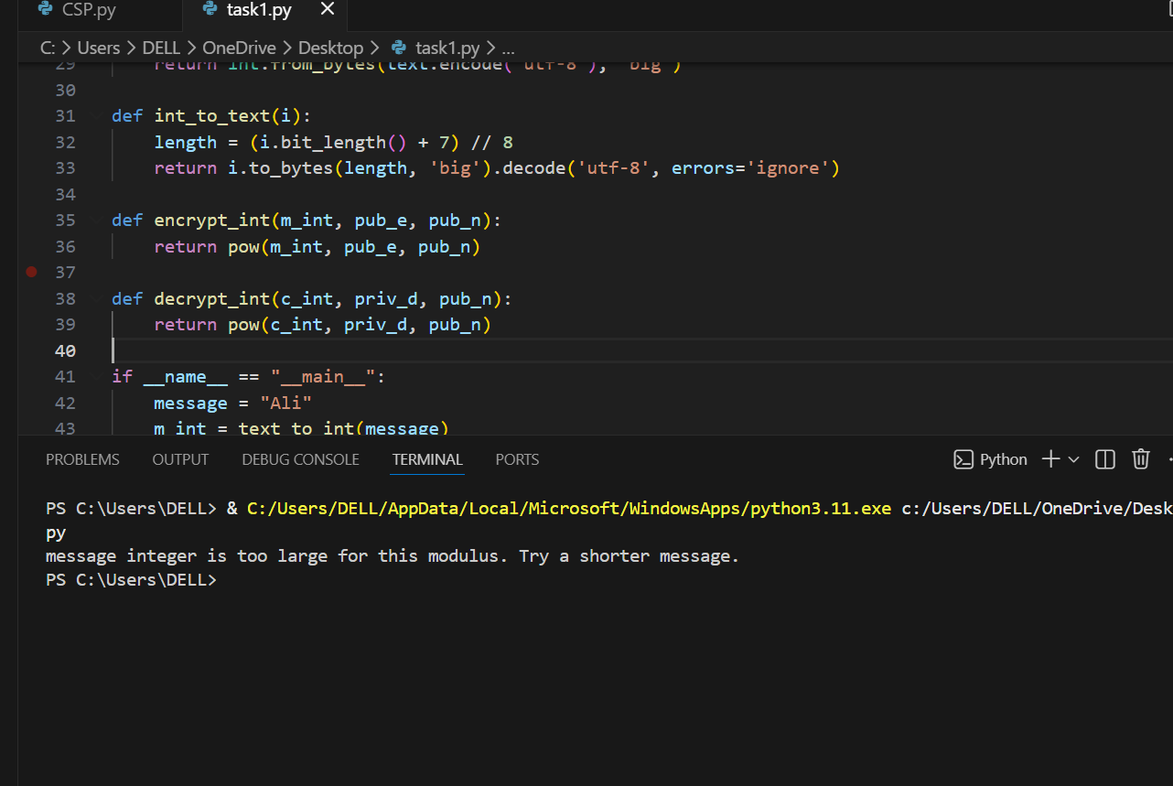

TASK2
- generate_keypair uses RSA.generate with key size 2048 bit to create a strong pair.
- PKCS1 OAEP is used for encryption because it offers probabilistic padding and prevents deterministic attacks.
- Outputs are printed in pem and ciphertext hex for the report.
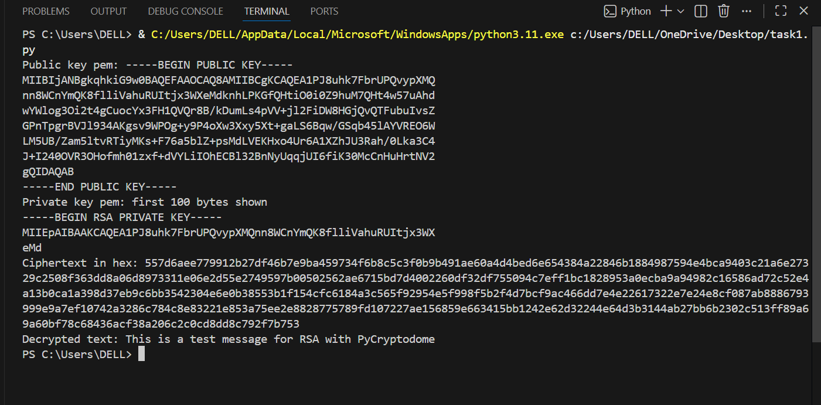

Task3
1.The key generation is same as task 2.
2.SHA256 is used to hash the message before signing.
3.pkcs1_15 is used to sign the hash with private key and to verify with public key.
4.The demo shows verification passes for original message and fails for the modified message.
